**Subject: Big Data Engineering (DJ19DSL604)**

**AY: 2022-23**

**Experiment 6**

**(Data Warehouse)**

**Aim:** Implement data warehousing using HIVE.

**Theory:**

**Introduction to HIVE**

Hive as an ETL and data warehousing tool on top of[Hadoop](https://www.guru99.com/bigdata-tutorials.html)ecosystem provides functionalities like Data modeling, Data manipulation, Data processing and Data querying. Data Extraction in Hive means the creation of tables in Hive and loading structured and semi structured data as well as querying data based on the requirements.

For batch processing, we are going to write custom defined scripts using a custom map and reduce scripts using a scripting language. It provides[SQL](https://www.guru99.com/sql.html)like environment and support for easy querying.

**HIVE Architecture**

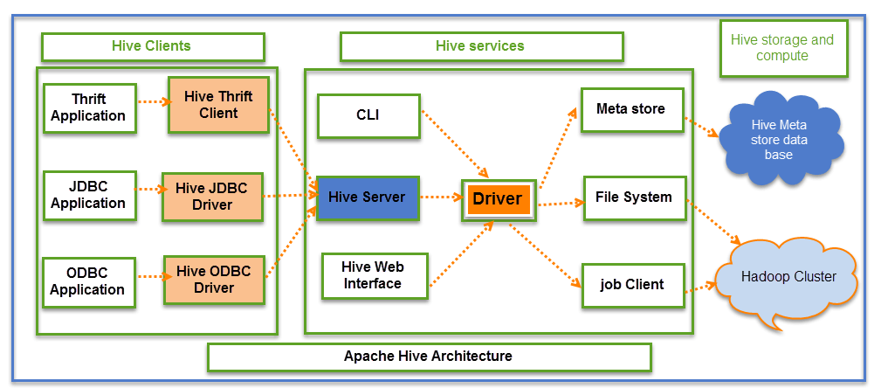

**Job execution flow:**

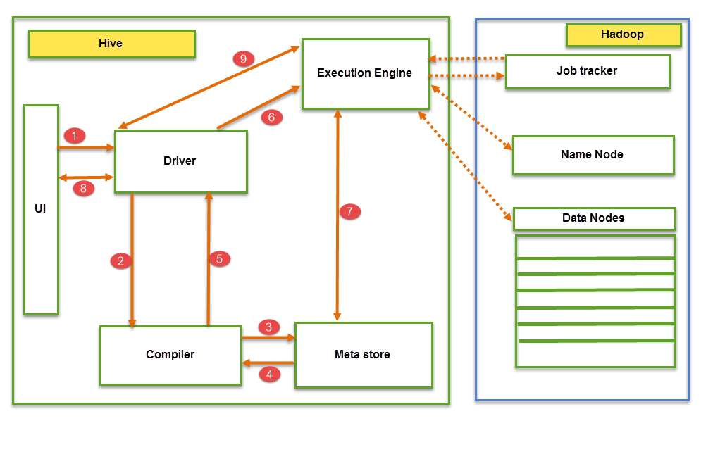

## **Different modes of Hive:**

Hive can operate in two modes depending on the size of data nodes in Hadoop.

These modes are,

* **Local mode**
* **Map reduce mode**

When to use Local mode:

* If the Hadoop installed under pseudo mode with having one data node we use Hive in this mode
* If the data size is smaller in term of limited to single local machine, we can use this mode
* Processing will be very fast on smaller data sets present in the local machine.

When to use Map reduce mode:

* If Hadoop is having multiple data nodes and data is distributed across different node we use Hive in this mode
* It will perform on large amount of data sets and query going to execute in parallel way
* Processing of large data sets with better performance can be achieved through this mode

**Lab Assignment:**

1. Installation of HIVE.











1. Implement the following SQL queries in HIVE on any database:
   1. Create Database
   2. Order by Query
   3. Group by Query
   4. Sort By
   5. Cluster By
   6. Distribute By

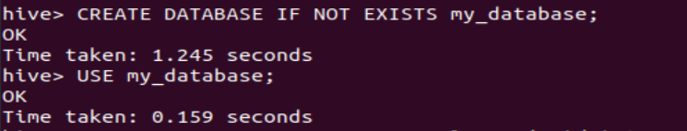

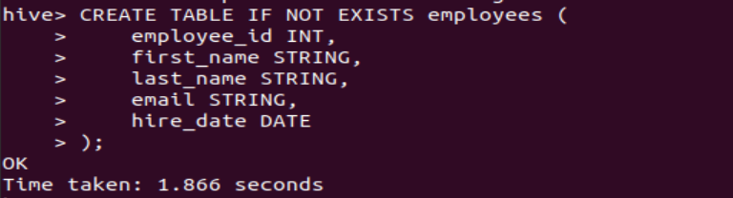

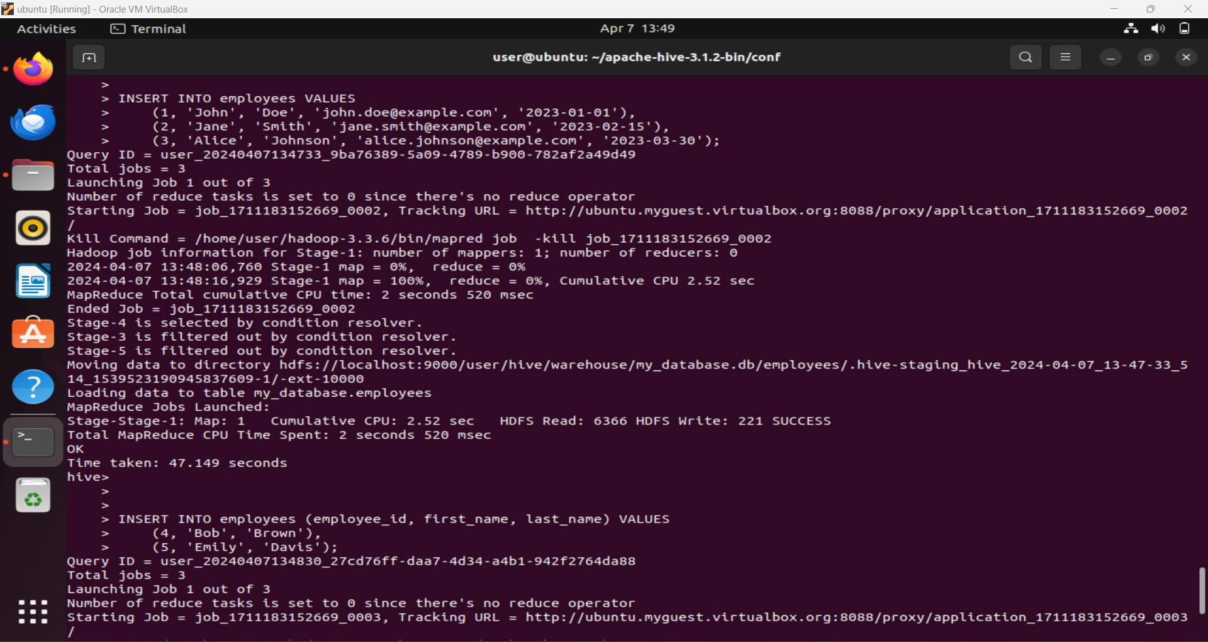

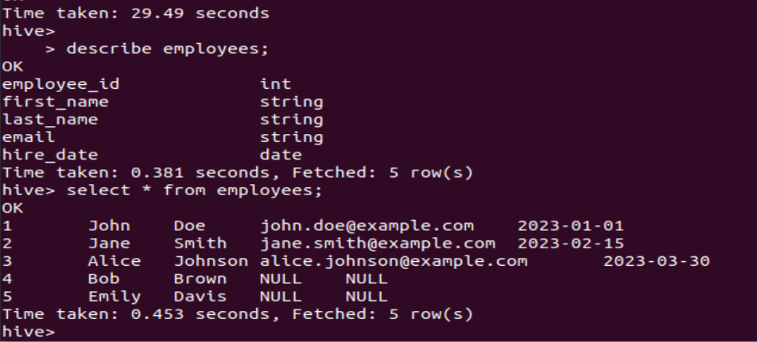

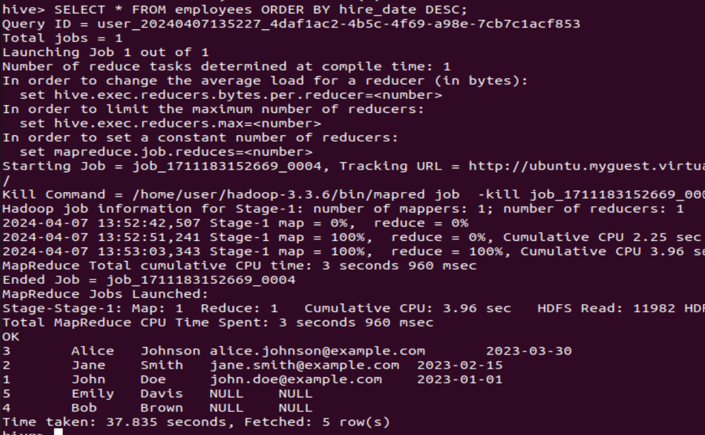

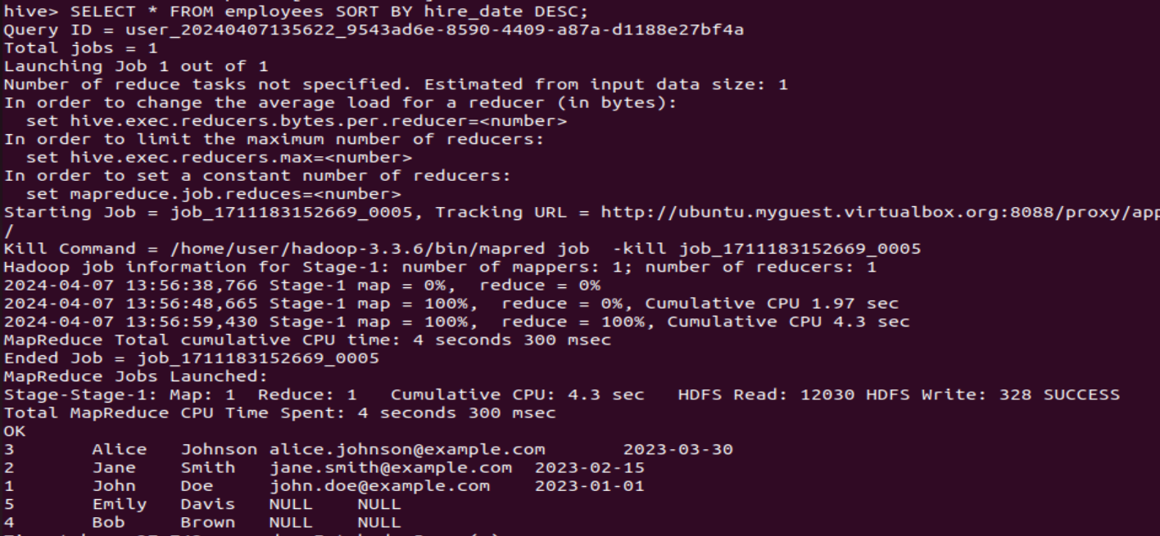

1. Working with HIVE ETL:
   1. Structured Data using Hive.
   2. Semi structured data using Hive (XML, JSON).

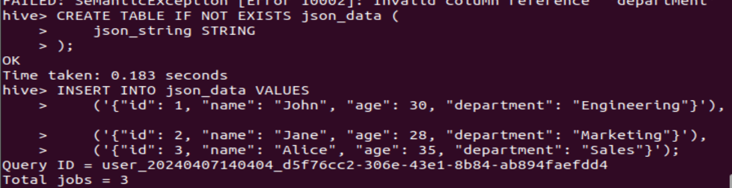

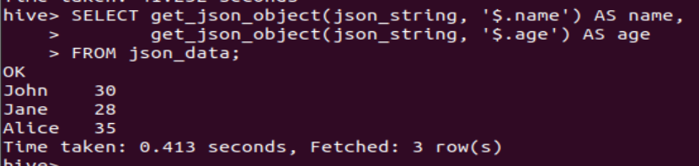

**Conclusion:**

This experiment showcased the versatility of Hive as an ETL and data warehousing tool within the Hadoop ecosystem. By leveraging its SQL-like interface and integration with Hadoop, users can efficiently process and analyze large volumes of data for various analytical and reporting purposes. Additionally, Hive's support for both structured and semi-structured data makes it a powerful tool for handling diverse data sources in a data warehouse environment.